**Network Task**

1.Get me the IP address of a particular domain (guvi.in). How do I find my CPU/memory usage of my server? Test the connectivity between 2 nodes?

1. To obtain the IP address of guvi.in, **nslookup** or **ping** command can be used in linux.

**nslookup guvi.in**

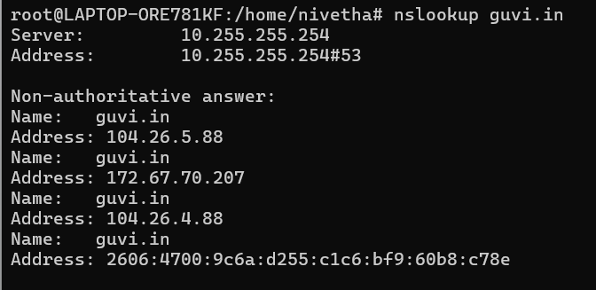

**dig guvi.in**

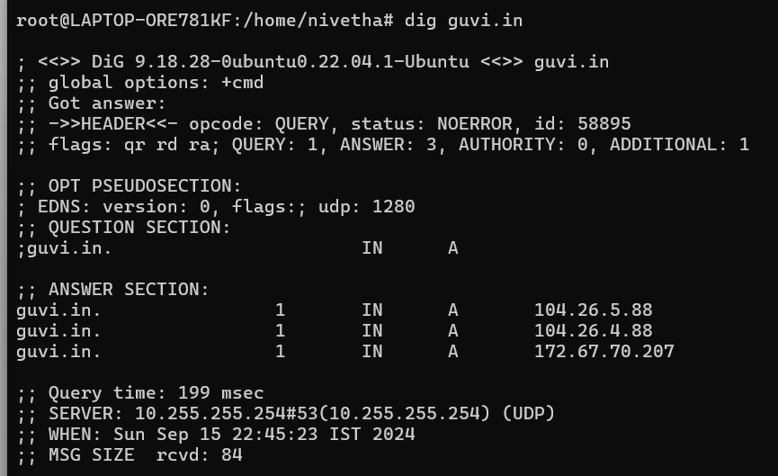

1. To find CPU/Memory usage of my server **top or htop** is used. To find Memory usage,

**free -h** is used.

**top** command, press **q** to exit the top command

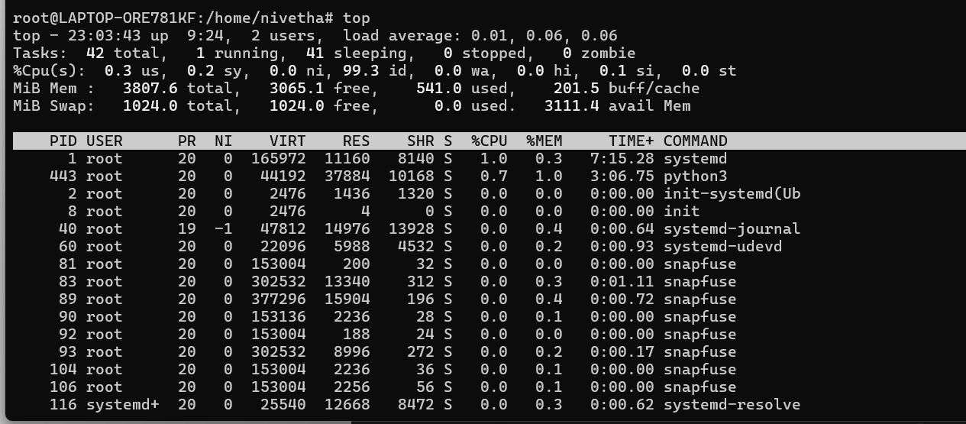

**htop** command, press **F10** to exit the htop command

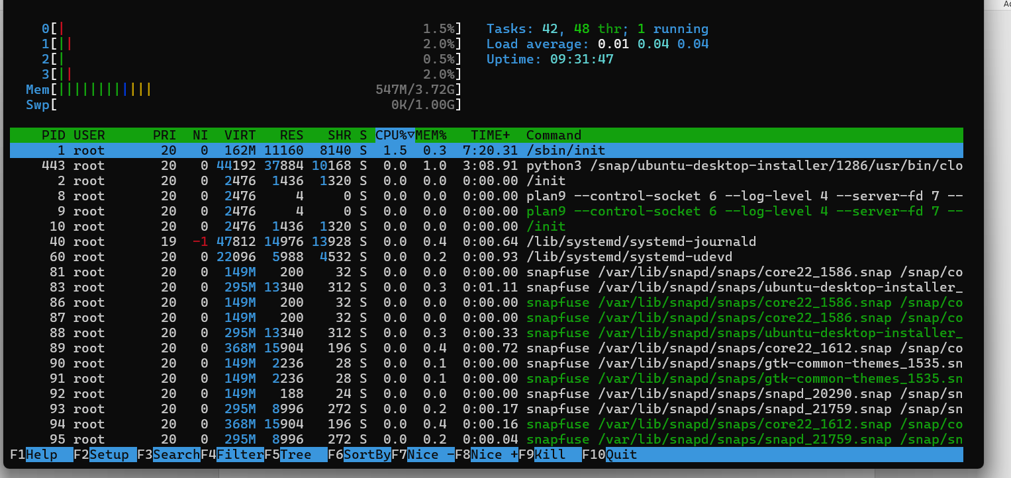

**Free -h**



1. To test the connectivity between 2 nodes, ping or traceroute command is used

**Ping guvi.in**, use **ctrl c** to stop the ping command

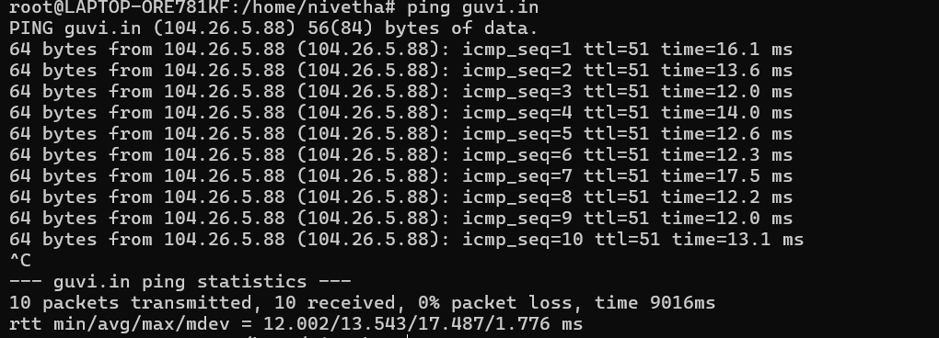

**traceroute guvi.in**

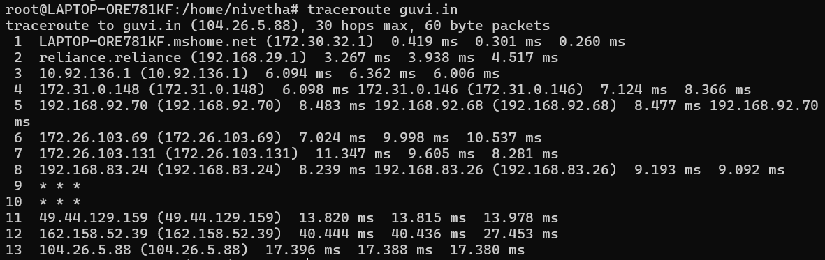

2.I have deployed an application in guvi.com:9000, and logs show my app is running, but I’m unable to view the page. Check whether my port is open or not ?

A. Ensure guvi.com resolves to an IP address using **nslookup or dig**

**nslookup guvi.com**

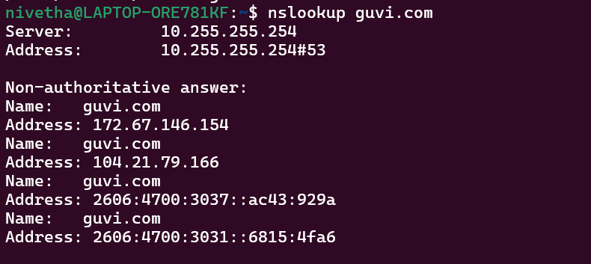

**dig guvi.com**

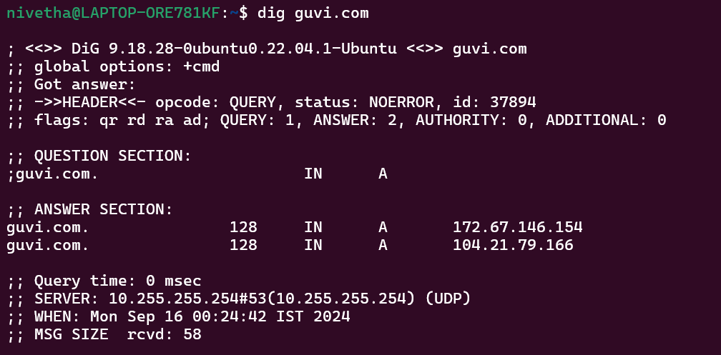

B. To check the network connectivity use ping

**ping guvi.com**, **ctrl c** to stop the command

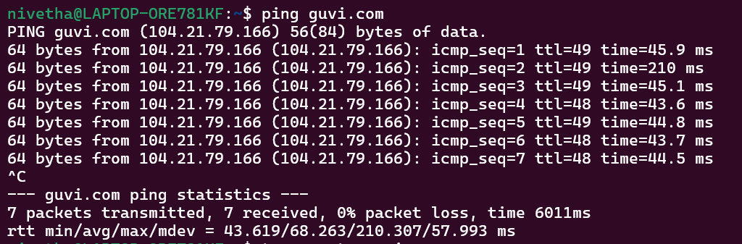

1. To trace the route, use traceroute

**traceroute guvi.com**

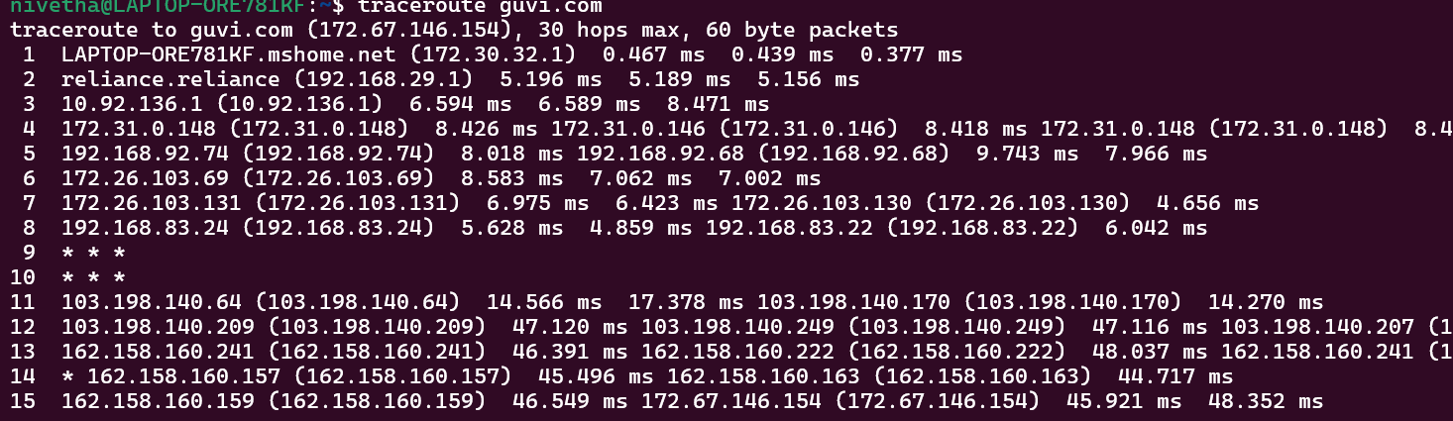

1. To check the port connectivity
2. **telnet** can be used

**telnet guvi.com 9000** – if the port is open the connection will be established. But here the connection is failed which confirms the port is closed or blocked

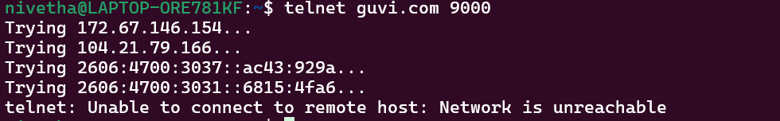

1. **netcat** is the versatile tool which can be also used to check port connectivity

**nc -zv guvi.com 9000** – the output is failed connection. This generally indicates that the connection request did not receive a response from the server, and it often suggests that the port may be closed, blocked, or otherwise unreachable.

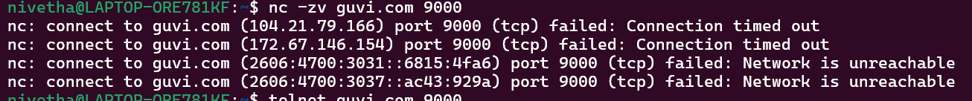

1. If the service on port 9000 is HTTP-based, curl can be used.

**curl -I** [**http://guvi.com:9000**](http://guvi.com:9000) – the timeout message further indicates the port might not be accessible.



1. Using nmap to scan the port

**nmap -p 9000 guvi.com** – since nmap is not available installing using the below command (given by ubuntu)

**apt install nmap # version 7.91+dfsg1+really7.80+dfsg1-2ubuntu0.1**

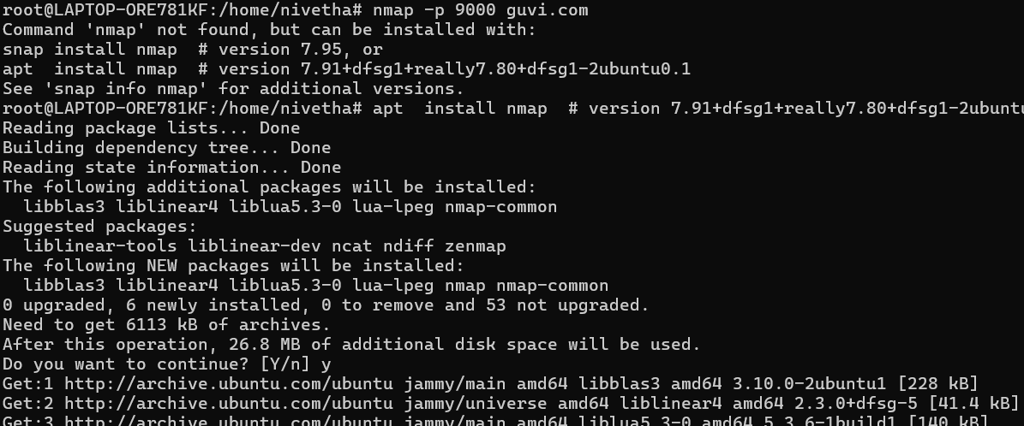

Once installed, using the command, **nmap -p 9000 guvi.com**. The filtered output shows that the port is blocked or filtered by the security group

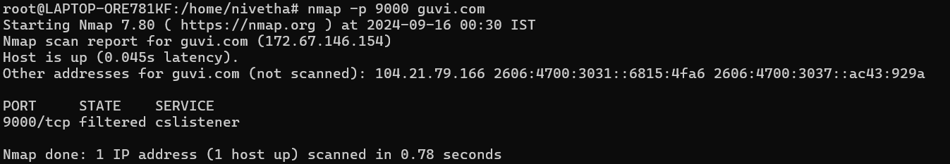

**Conclusion**: The port might be closed rather than being open since the connection is not established with various tools.